Automation of Cloud Formation

* **Deploy** an AWS CloudFormation stack with a defined Virtual Private Cloud (VPC), and Security Group.
* **Configure** an AWS CloudFormation stack with resources, such as an Amazon Simple Storage Solution (S3) bucket and Amazon Elastic Compute Cloud (EC2).
* **Terminate** an AWS CloudFormation and its respective resources.

Step 1:

Uploading a template that is written in YAML

Step 2:

Step 3: default

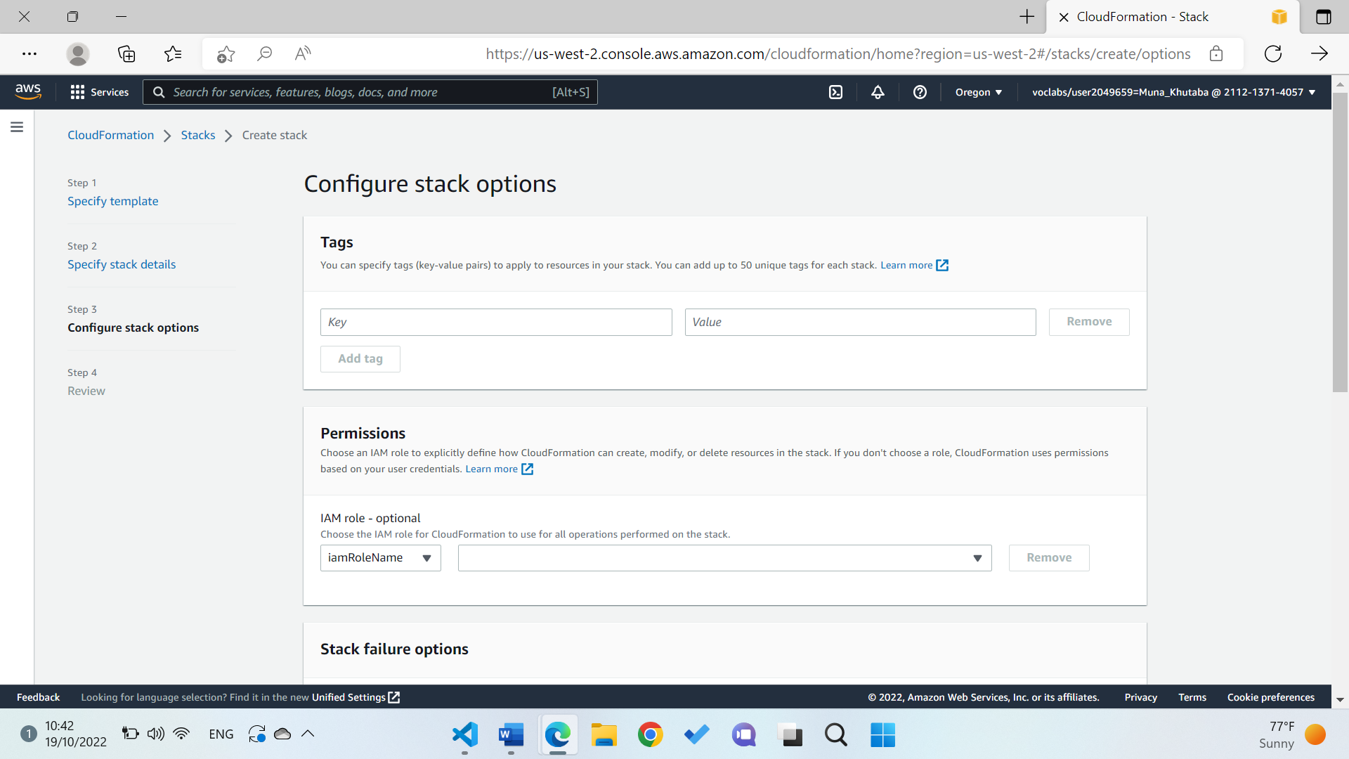

Step 4 review and create stack.

The resources being procced by CloudFormation

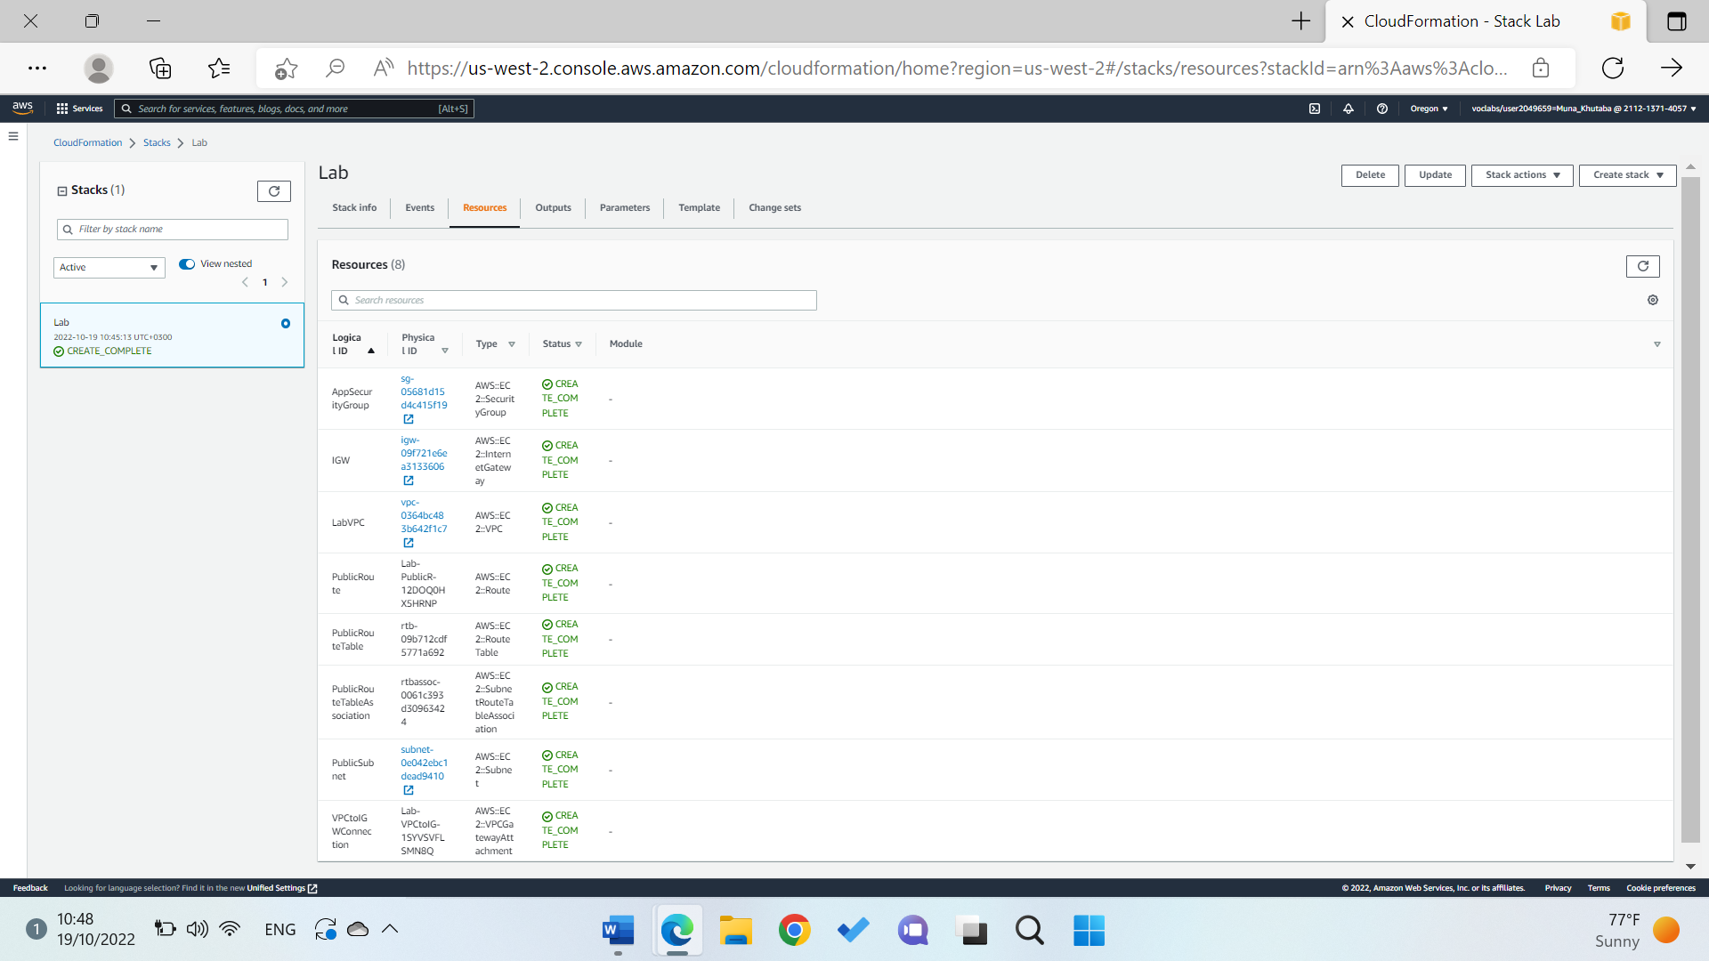

Now adding an Amazon S3 bucket to the stack that we created earlier

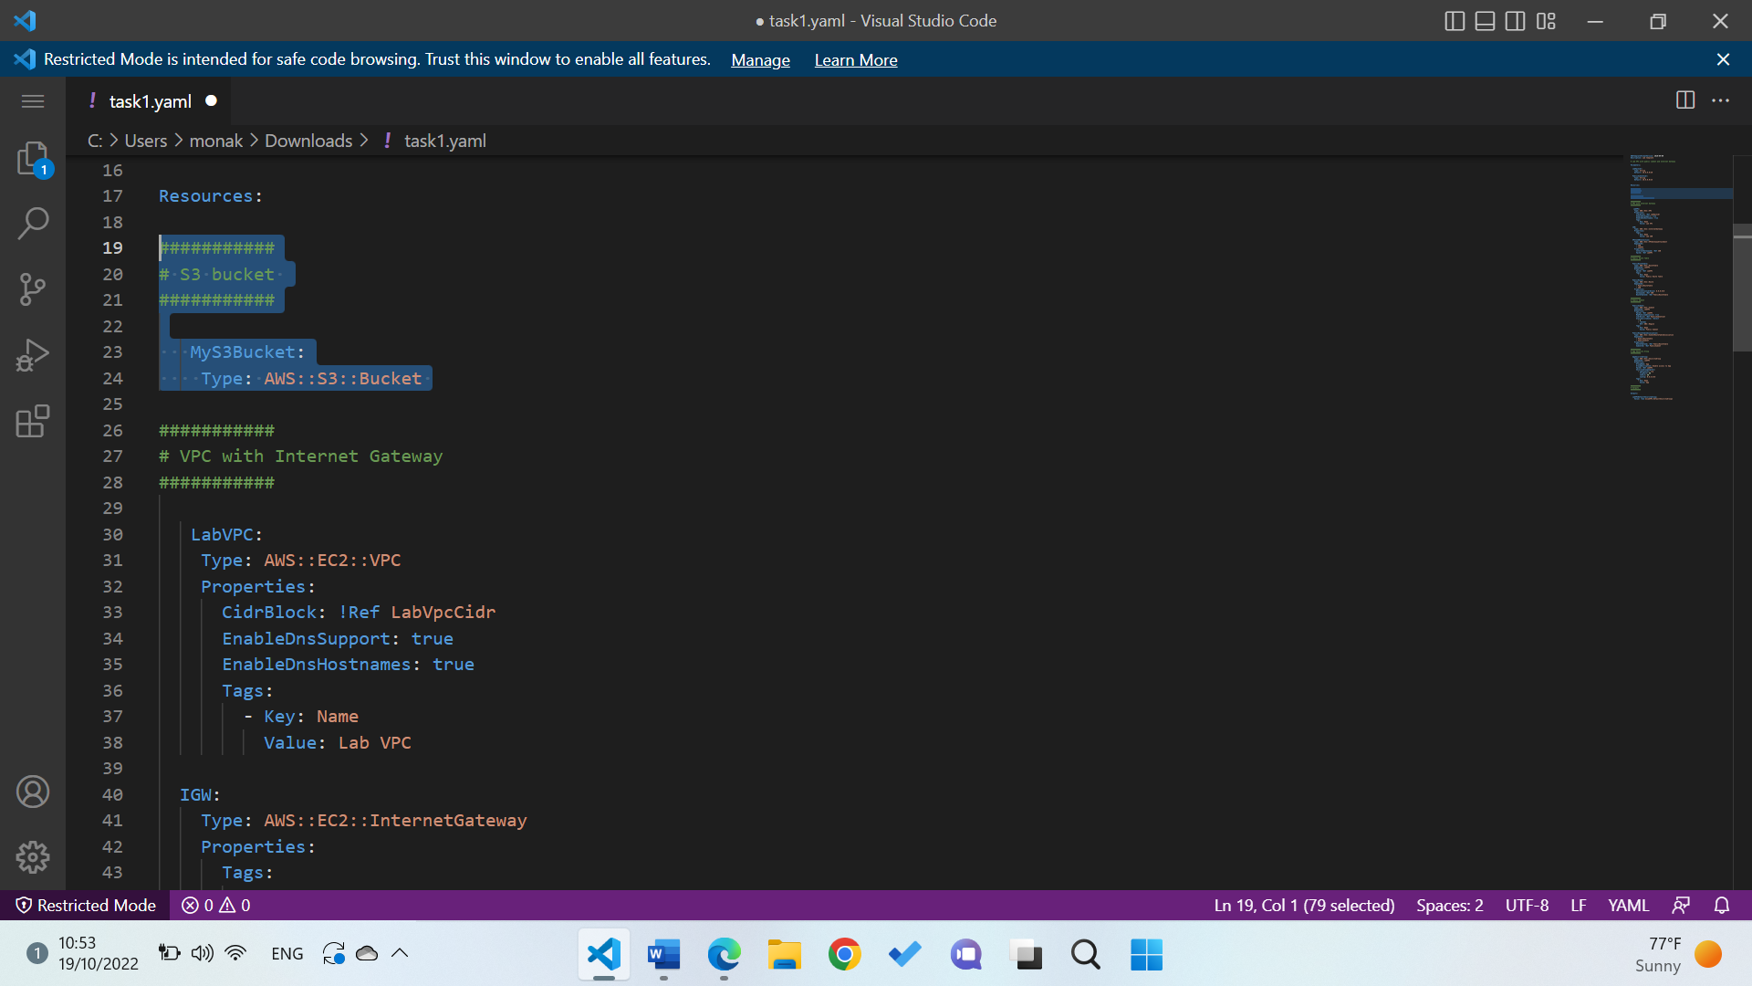

Then update the stack and make sure the making of an s3 bucket is completed

Now adding an EC2 instance to the stack:

First, we update the parameters to provide a value for the Amazon Machine Image AMI. (it retrieves the latest AMI in this case Amazon Linux 2

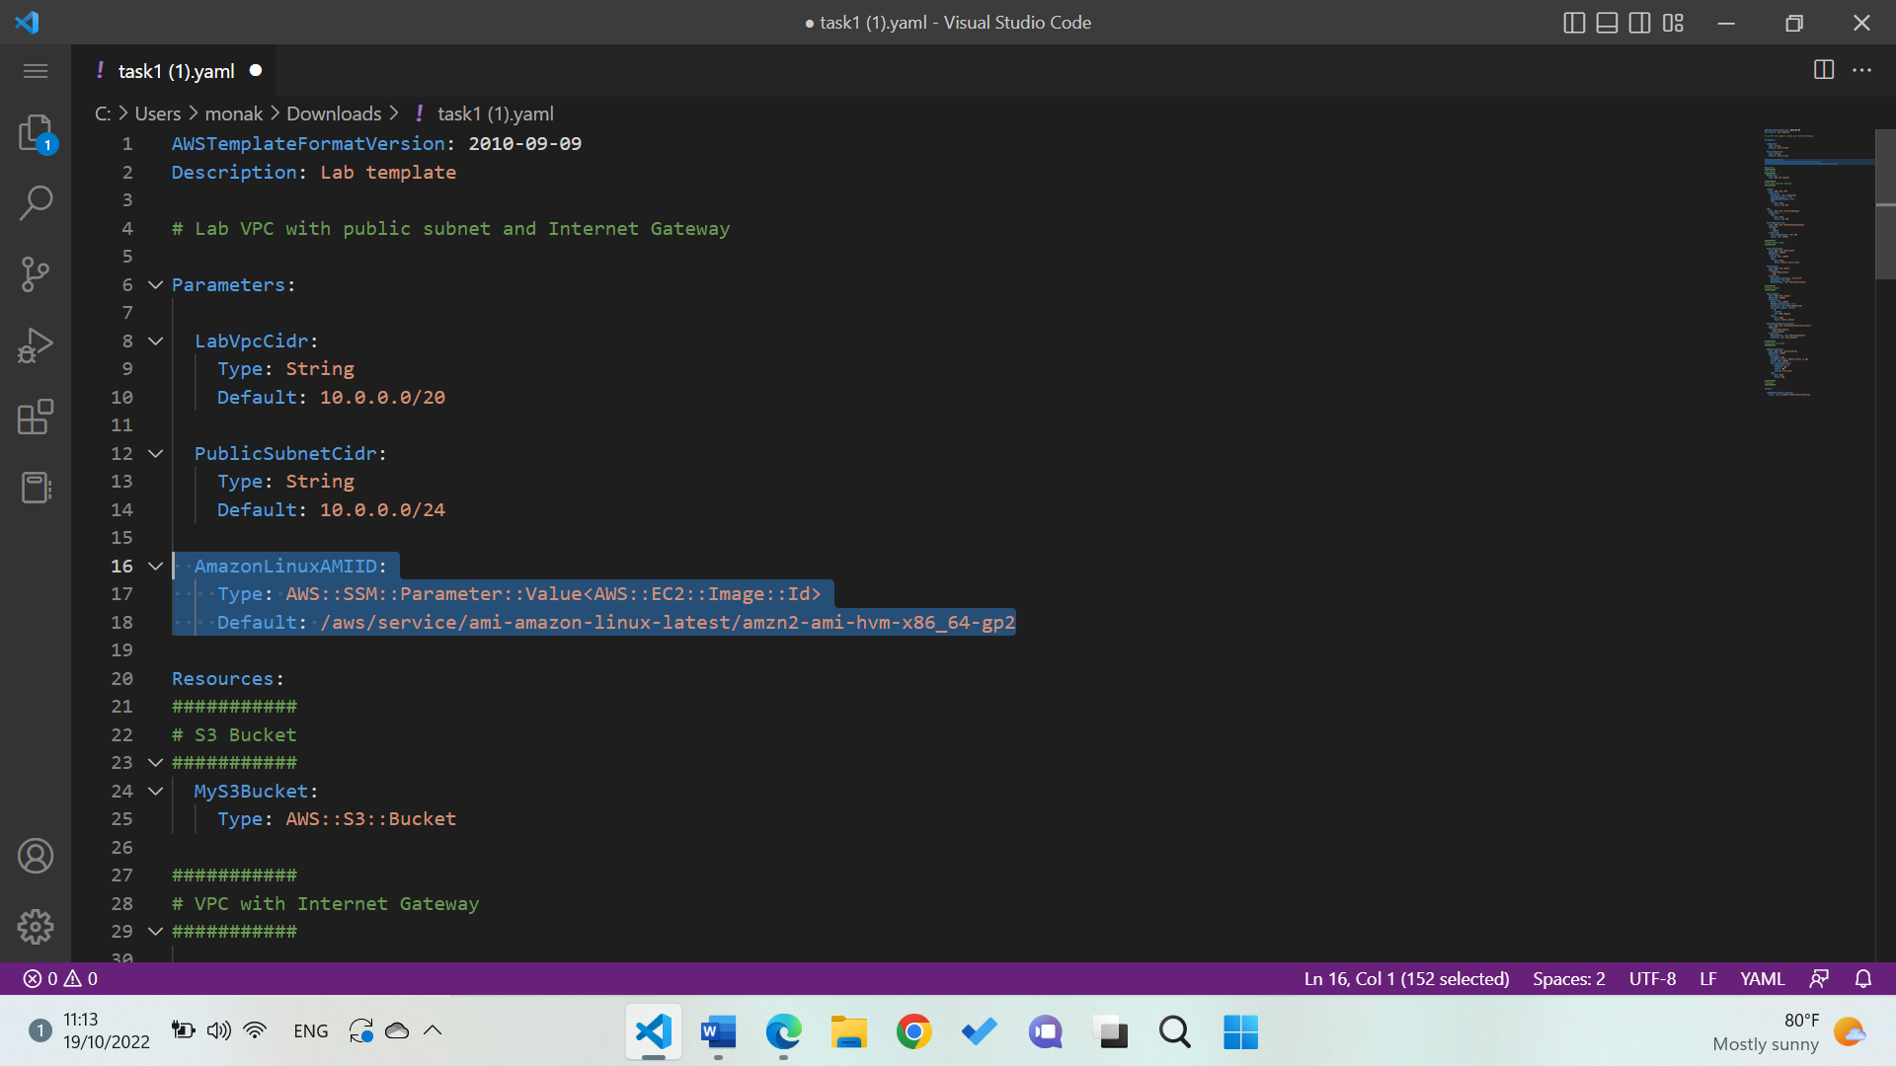

Adding Amazon EC2 properties as follows:

Go back to resources and make sure that the ec2 instance is completed

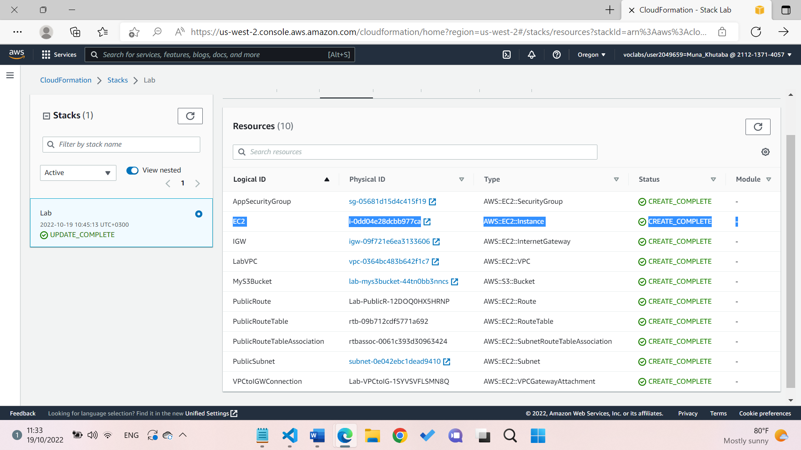

Now the last step is to delete the stack

Making sure the stack is deleted

